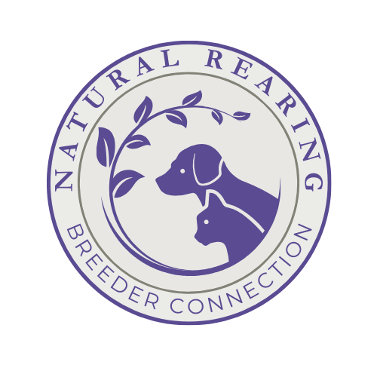

**APPLICATION FOR MEMBERSHIP**

**Natural Rearing Breeder Connection**

Name_______________________________________________________________Date______________________

Address___________________________________________________________City________________________

State/Province _______________________________ Zip/Postal Code_______________

E-Mail_______________________________________________________________________________________

Kennel Name_____________________________________________________Phone________________________

Website Address: ______________________________________________________________________________

E-Mail Address: ________________________________________________________________

Social Media Handles and any alternate SM names: __________________________________________________

**Please send a FB friend request to Krystal Beers.**

Number of years feeding raw:

Number of years not vaccinating:

Breeds You Own (list number of dogs & breeds):

Membership in kennel/breed clubs (list):

Why do you want to join the NRBC?

What cleaning, laundry, and grooming products do you use?

In what objective venue(s) do you test your breeding program?

What health tests have you performed on your breeding dogs?

**If approved for membership, I agree to abide by the Code of Ethics of the Natural Rearing Breeder Connection as signified by my signature herein and on the copy attached.**

**APPLICANT SIGNATURE____________________________________________________**

**Natural Rearing Breeder Connection**

**CODE OF ETHICS**

**This Code of Ethics is established in accordance with the objectives of the Natural Rearing Breeder Connection (NRBC). It is presented as a guideline for the use of NRBC members when buying, breeding, selling, and exhibiting their cats. Violators of the NRBC Code of Ethics will be subject to loss of membership privileges.**

**As a member of the Natural Rearing Breeder Connection, I state that:**

* I am committed to feeding my dogs/puppies on a completely raw (SARF, BARF) diet and do not feed processed kibble or canned foods even as a supplement.
* I do not vaccinate at all (except where required by state law).
* I do not use toxic chemical products in, on, or around my dogs/puppies such as flea/tick preventatives, household cleaners, laundry products, air fresheners, lawn and garden -cides, etc.
* I have been feeding a raw diet to my dogs and weaning puppies onto raw for at least three (3) years.
* I breed my dogs with care and attention for the preservation and improvement of my chosen breed(s).
* I test my breeding program in an objective venue such as conformation showing, work, tests, trials, etc.
* I research health, temperament, and conformation for each litter I breed.
* I ensure that my dogs offered for stud, and the bitches that are accepted for stud service are in good health, free from communicable diseases, and structurally sound.
* I rear the puppies in my home where they will get a maximum of human contact.
* I health test my breeding dogs/cats for the diseases and/or health problems prevalent in the breed and provide copies of all appropriate health and genetic clearances to buyers.
* I provide health and temperament information on my breed(s) in general as well as on my specific dogs/puppies to all prospective buyers.
* I register my litters with the American Kennel Club, Canadian Kennel Club, United Kennel Club, or other breed or breed-specific registries that have similar standards.
* I provide all required documentation with each puppy in accordance with the rules and regulations of the registry.
* I personally and carefully screen each prospective buyer to ensure that the home is appropriate for the breed and the individual animal, and I make every effort to place them in homes where the new family will continue to rear them “Naturally”.
* I remain available to my puppy buyers for the lifetime of the puppy to mentor if need be and provide education in Natural Rearing.
* I accept puppies back at any time during their life, ensuring that each animal I breed has a home for its lifetime.
* All puppy placements are done by me, the breeder, never by third parties such as brokers, dealers, or wholesalers, nor through auctions or as prizes.
* I will sell no puppy/dog to a commercial facility, lab, broker, pet shop, mill, or their agent.
* I refuse to sell any puppy/dog to a buyer who cannot or will not provide evidence of ability to properly care for the animal.
* I hold myself responsible for the welfare of every animal I breed and/or sell.
* I will conduct myself at all times in a professional manner so as to reflect credit on Natural Rearing.
* I am a member in good standing of a breed-related, show-related, canine education-related, working dog-related organization.

Signed: __________________________________ Dated: _____________

Please Email photo of a hand-signed copy to [nrbreeder@outlook.com](mailto:nrbreeder@outlook.com) or mail the signed hard copy to:

**Krystal Beers**

- NRBC

19 Heritage Ln

Republic, WA 99166

**Additional information we can share about your breeding program if you are approved:**

Do you use a socialization/enrichment program with your litters? Yes ____ No ____

If “no”, do you do ENS or any other socialization or training with your puppies – please explain:

Do you educate your puppy buyers on the benefits of raw feeding and not vaccinating or using toxic chemicals? Yes _____ No _____

Do you have a litter due or a current litter where all the puppies are *not* reserved yet?

Yes ____No ____

If yes, would you like to purchase a litter listing on the website?

Yes ____No ____

Please list two references that we may contact:

If you have any of the following skills, would you be interested in one of the following volunteer positions within the NRBC?

___Photoshop/graphics

___Advertising

___Brochure Preparation

___Newsletter or Publishing

___Photography

___Printing

___Scientific Research

___Education

___Writing

___Newsletter Columnist

___Publicity

___Other

***Thank you for taking the time to apply for membership!***